**CHALLENGES**

**NAME: RAKESH – 15**

1. Launch one aws ec2 and install jenkins.

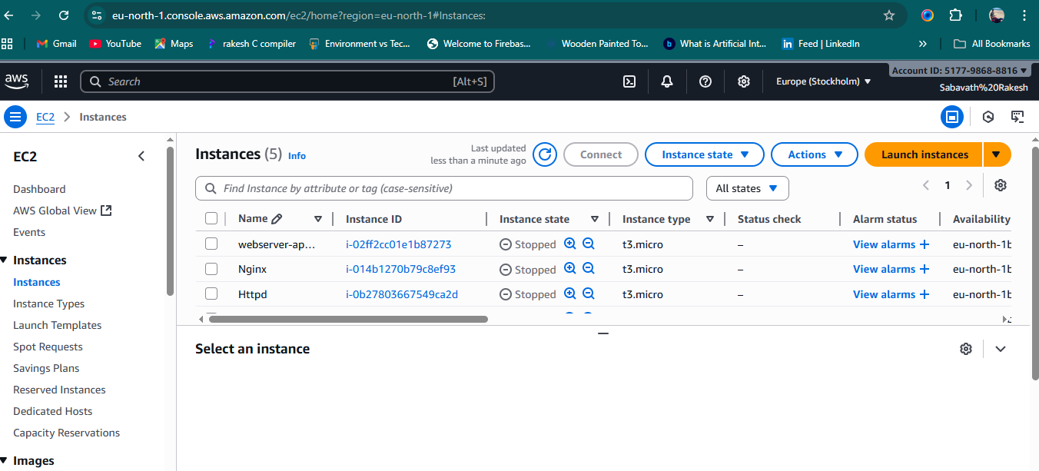

1. Setup Apache Tomcat on Ubuntu Virtual Machine

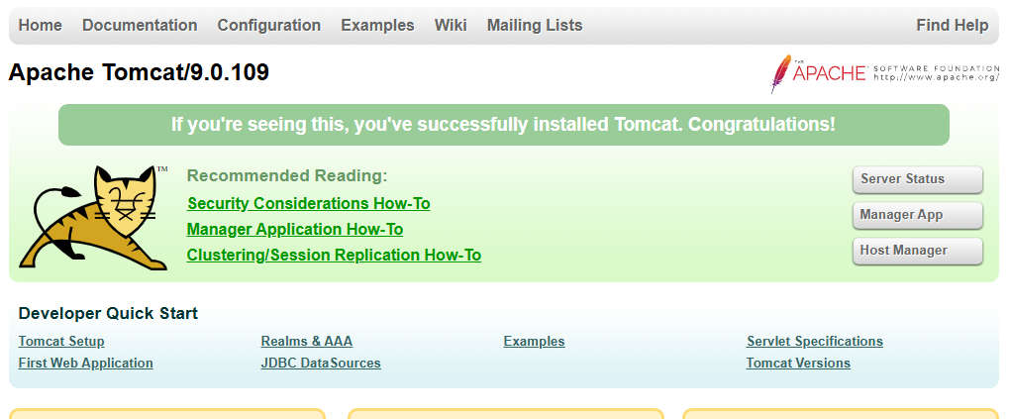

1. Setup Docker Desktop on your local windows

